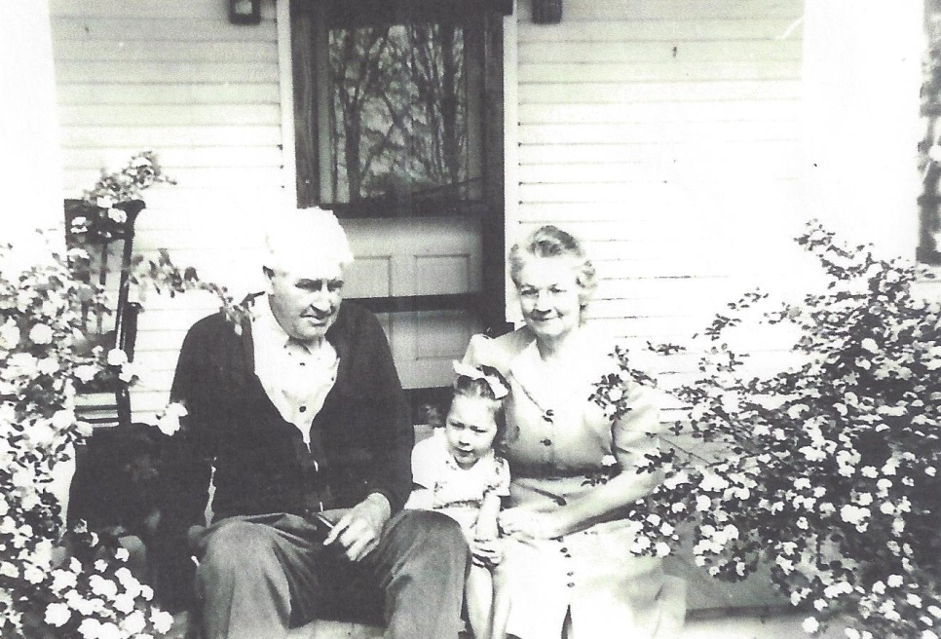

**(l-r) Earl Russell Wolfe, Suzanne Kay Wolfe,**

**Josephine Sybil Worthen Wolfe**

**Walnut Bend, Wolfe Road – 1945 or 1946**

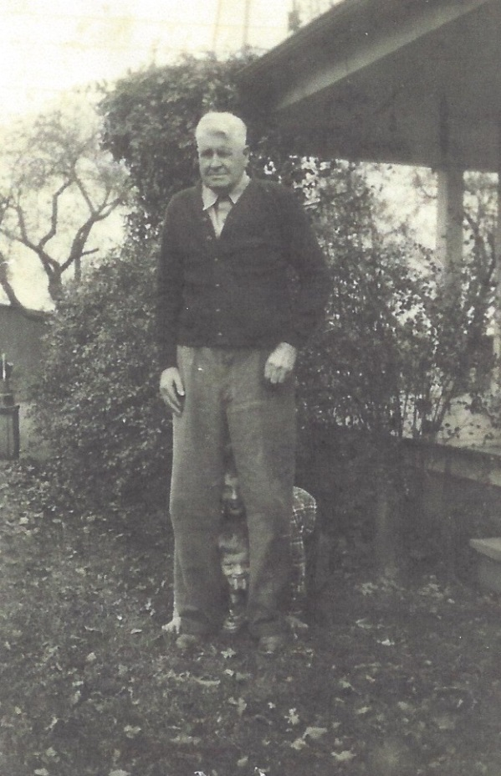

**Earl Russell Wolfe on 68th Birthday, plus two more**

**The two children are believed to be Mark and David List**

**Photo taken – 18 November 1946**